Chapter 12, Problem 7.

Obtain the line currents in the three-phase circuit of Fig. 12.42 below.

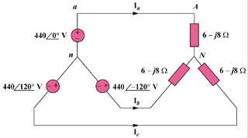

Figure 12.42
For Prob. 12.7.

